**Real number system**

**Asst. Prof. Dr. Supotch Chaiyasang**

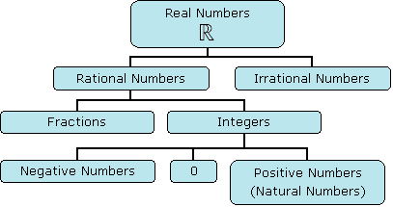

In modern mathematics, mathematicians developed two approaches in studying real number system as following :

1. First approach was developed through natural numbers, integers, rational numbers, irrational numbers, and real numbers by using Piano’s Postulates, ordered pairs, and Dedakin’s cuts to define natural numbers, integers and rational numbers, and irrational numbers respectively.

2. Second approach was developed through axioms of complete ordered field ( R,+,.) to construct properties of real numbers and then, construct subsystems of R such as 

In grade 10 , we use the second approach. So, we will start through axioms of complete ordered field.

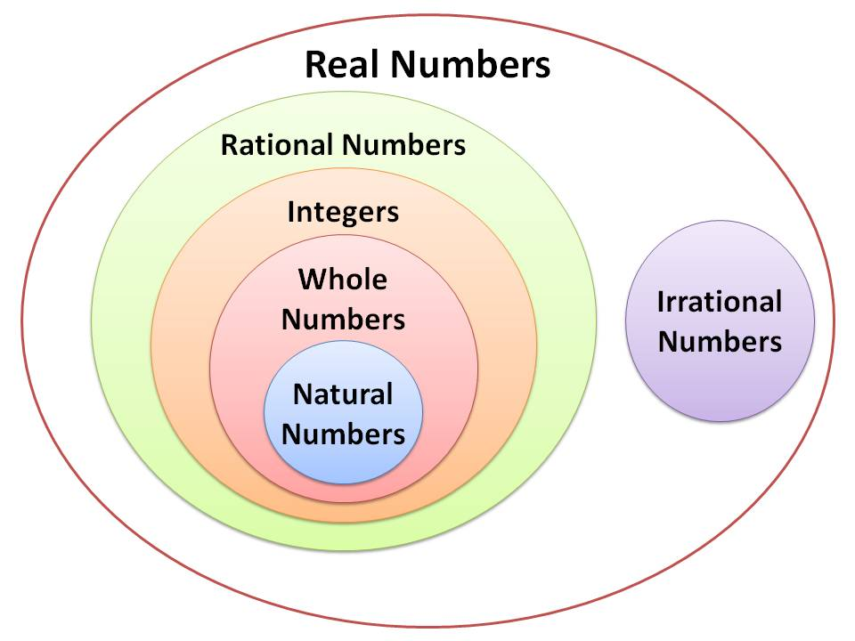

The set of real numbers consists of elements symbolized by a,b,c,…,0,1 with two binary operations (addition and multiplication denoted by + and ). Each element of R is called a real number.

R (+,) is the complete ordered field. It satisfies the following axioms (properties).

1. Field axioms
2. Ordered axioms
3. Completeness axioms

**Field axioms (properties)**

For any a, b, and c in R,

 :  and  (commutative property)

 :  and  (associative property)

 :  (distributive property)

 : There exists an element in R, denoted by “0”, such that 

for every a in R. (additive identity)

 : There exists an element in R, denoted by “1”, different from 0,

such that  for every a in R . (multiplicative identity)

 : For each a in R, there is an element in R denoted by “-a”, such that

. ( -a is called additive inverse of a. )

 : For each “a” in R except 0, there is an element in R denoted by “”, such

that . ( is called multiplicative inverse of a. )

Note : 1) The symbol = represents an equivalence in R and is used to assert the fact

that two particular symbols represent the same element in R.

2) Closure properties of + and  is true because + and  are binary operation.

**Equality Axioms**

For all a,b,c and d in R,

 :  (reflexive)

 : if , then **.** (Symmetric)

 : if and , then **.** (Transitive)

 : if and , then **.**

 : if and , then **.**

The following theorems are the consequences of field axioms. The proof of them are the same as those in abstract algebra.

**Theorem 1** If a and b are any elements in R such that , then .

**Theorem 2** If a, b and c are any elements in R such that .

**Theorem 3** For any a in R, .

**Theorem 4** For any a and b in R, .

**Theorem 5** The equation  has the unique solution.

**Theorem 6** For any a, b, and c in R,

1. If  and , then .
2. If  and , then .
3. If , then  .
4. If , then  .
5. For any a in R, .
6. For any a and b in R, .

i , 

ii 

iii .

**Definition** : 1) a – b is defined as .

2)  is defined as , .

**Theorem 7** For any a, b, c, and d in R,

1. , , 
2. ,  , 
3.  iff , 
4. , 
5. , 
6. , 

**Order axioms**

We assume that R (+,.) has an order relation < and satisfies the following axioms.

. If a and b are in R, then only one of the following is true :

, , . (Trichotomy Law)

. If a, b, c are any elements in R such that  and , then (Transitive Law)

. If a, b, c are any elements in R such that , then .

. If a, b, c are any elements in R such that and , then .

Note : 1)  and  are the same statement.

2)  means  or .

3)  means  or  .

We say that “a” is positive when  and “a” is negative when .

 If , , and  then .

**Theorem 7.1** For any a and b in R,

 iff 

**Corollaries to theorem 7.1**

1)  iff .

2)  iff .

3)  iff .

By , we can sort all real numbers into three disjoint subsets :

1. The set P of all positive real numbers.
2. .
3. The set -P of all negative real numbers.

**Theorem 8** If  and , then  and .

**Theorem 9** If  and , then .

**Theorem 10** If  and , then  and .

**Theorem 11** If , then .

**Theorem 12** For ,  iff .

**Theorem 13** For ,  iff .

**Theorem 14** If , then .

**Theorem 15** .

**Theorem 16**  iff ( and ) or ( and ).

**Theorem 17**  iff ( and ) or ( and ).

**Theorem 18**  iff .

**Corollary to theorem 18** : .

**Example** : Find the solution set of

i ,

ii , and

iii .

**Absolute Values**

**Definition : If , the absolute value of a, denoted by , is defined by**

** if **

** if .**

**Theorem** : For all real numbers a, b, and c,

1. 
2. 
3. , 
4. i) if , then .

ii) If , then  or .

1. 
2.  (Triangle Inequality)

**Corollary** : For any a, b, in R,

1. 
2. 
3. For any  in R,   .

**Example** : a) Find solution set of each inequality.

i 

ii 

1. Suppose the function f is defined by  for .

Find a constant M such that  for all  satisfying .

**Exercises**

1. Let . Show that :
2.  (b) 
3. If , show that  iff .
4. If , , show that  iff + = .

Interpret this geometrically.

1. Find all that satisfy the following inequalities.
2.  c) 
3.  d) 
4. Show that  iff 
5. If  and , show that . Interpret this geometrically.
6. Sketch the set of pairs  in  that satisfy :
7.  d) 
8.  e) 
9.  f) 

**Subsystems of the Real Number System**

**The system of integers**

We know from theorem 15 that  ; that is, 1 is a positive real number. Then  by 03. The real number  is called “ 2 ”. By 02, . Similarly, we find that . These numbers are called positive integers. The set of positive integers is denoted by .

So, . The set of additive inverse of each positive integers is called the set of negative integers denoted by . So, .

The set  is called the set of whole numbers.

The union of , , and  is called the set of integers denoted by .

So,  or 

All integers are real numbers. So, they possess all properties of real numbers : field axioms, ordered axioms, equality axioms, and theorem 1 – 18.

**The system of rational numbers**

The numbers which can be written in the form  or ,  are called rational numbers and the set.

 is called is set of rational numbers.

It is obvious that 

Similarly, all rational numbers are real numbers. All of rational numbers satisfy all axioms and theorems as those of integers.

Note : Sometimes we called the set of natural numbers denoted by N

**Theorem 1** : (closure) The set of rational numbers is closed under addition and multiplication.

**Theorem 2** : (Density in Q) Given rational numbers a and b where , there exists a rational number c such that .

**Theorem 3** : Set of rational numbers is countable. That is there is 1 – 1 correspondence between set of natural numbers and set of rational numbers.

**Theorem 4** :  is not a rational number.

From theorem 4, we know that  is not a rational number but we don’t know whether it is a real number or not. To clarify this, we need the last axiom, the axiom of completeness.

**A axiom of Completeness**

**For every non-empty subset of R which is bounded above, there exists least upper bound.**

From this axiom, we can prove that  is a real number, the existence of .

Mathematicians can prove that for any positive integer a which is not a completing the square,  is a real number which is irrational.

Irrational from this theorem are  and soon.

Other irrational numbers that mathematicians can prove them are e, ect.

**Example** : Consider each of following statement whether it is true or not. If it is true, prove it.

If it is false, give a counter example.

Given rational numbers a and b and irrational number c and d.

1. If , ac is always irrational.
2.  is always irrational.
3. cd is always rational.
4. c + d is always rational.
5. a + b is always rational.

Set of irrational is denoted by ,

,

and .

**Exercises**

1. Consider whether each of the following statements is true or not.
   1. 1.01001000100001… is a rational number.
   2. 3.808808880… is not a rational number.
   3. 0.79779779779… is a rational number.
   4.  is not a real numbers.
   5. If x can be written in the form of repeating decimal, then x is a rational number.
   6. There exists a real number x such that 
   7. .
   8. There exists the greatest integer which is less than 1.99.
   9. There exists the greatest rational number is less than 10.
2. Prove that 0.999… = 1
3. Is  and 
4. Given  explain why .
5. Find the decimal representation of .