**Internship Instruction**

**Pre-Internship (2 Months)**

**Call CHM supervisor for visitation**

(around end of 2nd month)

**Write the purple report** (You can buy from the office)

CHM supervisor check it during visitation

**Host Supervisor evaluates** using the link or scan **QR Code**

https://forms.office.com/r/PXTA575XLM

**Write Pre-Internship Report**

Using the format from the website below.

<https://elchm.ssru.ac.th/nalin_si/course/view.php?id=14#section-6>

**Send Report (1st draft) to CHM Supervisor**

You may send .docx first, then print it using blue color cover

**Pre-Internship Presentation**

Present with Invigilator

(We will announce the name of invigilator later)

**Send Report (Final paper) and the purple book**

Send those 2 documents to CHM supervisor

(Please consult about channel of submission with your supervisor)

**Internship (4 Months)**

**Call CHM supervisor for visitation**

(around end of 4th month)

**Write the purple report** (same as you did in Pre-internship)

CHM supervisor check it during visitation

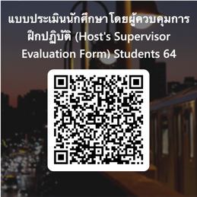

**Host Supervisor evaluates** using the link or scan **QR Code**

[https://forms.office.com/r/PXTA575XLM](Host%20Supervisor%20evaluates%20using%20the%20link%20or%20scan%20QR%20Code%20%20https:/forms.office.com/r/PXTA575XLM)

**Write Internship Report**

Using the format from the website below.

<https://elchm.ssru.ac.th/nalin_si/course/view.php?id=14#section-6>

**Send Report (1st draft) to CHM Supervisor**

You may send .docx first, then print it using pink color cover

**Internship Presentation**

Present with Invigilator

(We will announce the name of invigilator later)

**Send Final Report**

All information that you write as in the purple color book must be included in appendix (ภาคผนวก).

Then send it to your supervisor.

**Pre-Internship + Internship (5 Months)**

**All process will be the same as Pre-internship and Internship. However, Pre-internship period would be only 1 month, while Internship period is the same, 4 months.**

There will also have 2 visitation period, end of 2nd month for pre-internship and end of 5th month for Internship.